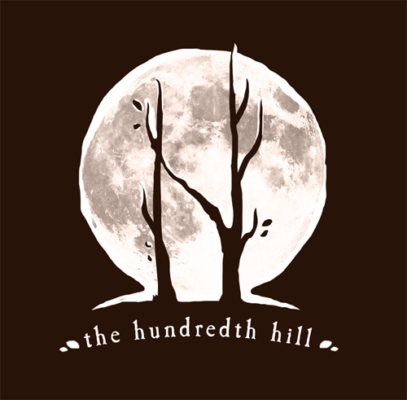
Mastering the Art of Song with Krista Detor & Amanda Biggs

Fall Weekend Series: October 7-29, 2017
___________________________________________________________________________________

WEEKEND 2: THE SETTING & SUBJECT OCTOBER 14th & 15th
___________________________________________________________________________________

SATURDAY, 10/14/17

9:00 - 11:00 A.M.
Mastering the Art of the Setting– with Krista Detor
If there truly is nothing new under the sun, how do we go about presenting subject matter in a way that is unique, meaningful, and accessible to our audience? The devil is in the details, and this class will offer techniques to draw the singular and unique out of common themes and universal ideas via detailed exploration of character, circumstance, setting, and frame of reference. Attendees will be expected to bring a song subject or notion for discussion and possible group workshopping. We’ll provide the pitchforks. ;)

11:00 – 11:15 A.M. – Break

11:15 – 12:35 A.M.
Mastering the Art of the Setting – with Krista Detor & special guest, Julie Hill
In storytelling and songwriting, the setting is intrinsic to the tale. We’ll take a look at stories and remembrances written by others, and translate settings from story to poem, prose and song. You never know what tiny stalks might crack the concrete and bloom fields of sunflowers.

12:40 – 1:30 P.M. – Lunch break
Wild mushroom and/or corn & chili tamales, Diablo slaw, assorted sweets & beverages*

1:45 - 4 P.M.
Mastering the Art of the Setting – LIVE! with Krista Detor
What if Mary had a little Llama, whose fleece was blue as sky? What happens when our age-old ideas are turned upside-down, and we’re forced to look at them in a way that challenges our conventions? Be prepared to pull a character, time frame, and possibly a rabbit out of a hat.

4:00 – 5 P.M.
Flat Earth Diary: Notes from the Bridge – with Krista Detor
Krista shares the setting, inspiration, and obstacles that led to the composition of her album, ‘Flat Earth Diary,’ and its companion book, ‘Notes from the Bridge.’ 25-foot seas, the world’s smallest blueberries, and the most breathtakingly beautiful sky full of stars you can imagine all await. Come along for the ride. There may even be a martini or two..

*Gluten-free and vegetarian/vegan options will be available upon request

SUNDAY, 10/15/17

10:00 - 11:45 A.M.
Mastering the Art of the Character – with Arbutus Cunningham
Bloomington treasure, Arbutus Cunningham, gives us insight into her process of character inspiration, as she takes us on an adventure into the natural (and, on occasion, the decidedly unnatural) world. She’ll bring to life gorgeous and delightful characters that will refine the way you look at the moon - especially on warm, summer nights when the jars of hot sauce on the basement shelves are chattering to each other til the wee hours.

11:45 – 11:55 - Break

11:55 – 12:35 A.M.
Mastering the Art of the Character – with Krista Detor
In order to uncover unique characters with universal messages and appeal, we’ll walk through a couple of simple but effective exercises in breathing new life into clichés, and uncovering the personality in any given earthly thing, animate or otherwise.

12:40 – 1:30 – Lunch break -
Vegetarian chili, corn fritters, caramel flan and assorted beverages*

1:45 – 4:00 P.M.
Mastering the Art of the Character - LIVE
Arbutus Cunningham and Krista Detor will create a song, live, by invoking Arbutus’ characters and improvised prose. Anything can happen as the two red-heads go at the process of pulling a story in song out of thin air.

*Gluten-free and vegetarian/vegan options will be available upon request

