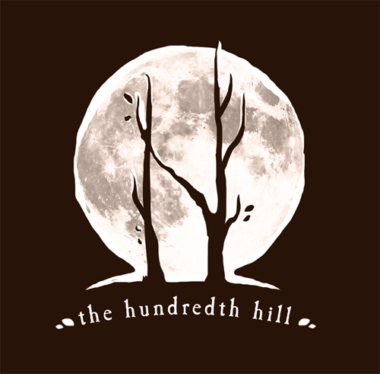
Mastering the Art of Song with Krista Detor & Amanda Biggs

Fall Weekend Series: October 7-29, 2017
_______________________________________________________________________________

WEEKEND 1: THE STRUCTURE OCTOBER 7TH & 8TH
_______________________________________________________________________________

SATURDAY, 10/7/17
9:00 - 11:00 A.M.
Mastering the Art of the Structure – with Krista Detor
Do you want to shake yourself out of a writing rut with some new notions? Are you looking to understand why we are drawn to the melodies and chords we’re drawn to? Or, are you simply sick of pretending to really know what I, IV, and V are, let alone I⁶, IV^{6/5} and V⁺⁷⁹? Sign up for this crash course, ‘cliff notes’ session in beginning music theory and how just a little knowledge of melodic and chordal relationships can take your writing and playing to a whole new level.

11:00 – 11:15 – Break

11:15 – 12:35 P.M.
Mastering the Art of the Structure - Vocal Masterclass with Amanda Biggs
The human voice is so much more than vibrating vocal chords. In this Masterclass, you’ll learn how the whole, amazing, human body is in play when you sing, and how its use or abuse can mean the difference between Adele and Elmo (seriously). In this class, you’ll see and hear both live examples and clips of successful and unsuccessful application of principle techniques in the professional music industry. Learn how to support your voice, increase your range, fine-tune your tone, and, most importantly, why mucus is your friend.

12:40 – 1:30 P.M. – Lunch break
Harvest soup, fresh bread by Keith Romaine, apple crumble and assorted beverages.

1:45 - 4 P.M.
Mastering the Art of the Structure – LIVE!
Applying the crazy Is, IVs, and Vs (and maybe even some German 7ths!) in a live songwriting workshop. See the Art of Structure in action!

4:00 - 5 P.M.
Exploring the Art of Place – with Krista Detor & Amanda Biggs
Take a fun and relaxed ‘Q & A’ trail walk and chat at The Hundredth Hill with Krista & Amanda, where we’ll explore the invaluable role of place and inspiration in songwriting*

*This walk is weather-dependent. If circumstances are unsuitable, we’ll hold Q & A in the recording studio.
__________________________________________________________________________

*Gluten-free and vegetarian/vegan options will be available upon request

SUNDAY, 10/8/17

10:00 - 11:50 A.M.
Mastering the Art of the Tone – with Krista Detor
This class provides a window into the art of tone in melody and chord structures, and how slight shifts can lead to dramatic results. We’ll experiment with varying intervals, minor and major settings, and alternate instrumentation (Bugle? Cigar Box Banjo? Autoharp?), as we uncover the world of expressive tonal possibilities. We might even determine, once and for all, whether D-minor really is the saddest of all keys.

11:50 – 12:00 P.M. - Break

12:00PM – 12:45 P.M.
Mastering the Art of Tone Vocal Masterclass - with Amanda Biggs
The nuances of effective use of tone will be explored in this vocal masterclass, in which one participant will be called upon (a/k/a/ ‘guinea pig’) to demonstrate techniques. You have to see this one to believe it – the smallest, subtlest shifts can create profound and beautiful results!

12:45 – 1:35 – Lunch break
Roasted Vegetable Tart, salad with dressings, glazed pumpkin scones, assorted beverages*

1:45 – 4:00 P.M.
Mastering the Art of Tone – LIVE!
The compositional and vocal techniques we’ve explored through the weekend will come to life in an exciting LIVE, group songwriting and vocalizing session, featuring the renowned improvisational vocalist Janiece Jaffe.

*Gluten-free and vegetarian/vegan options will be available upon request

